Project Development Phase Model Performance Test

Date | 06-02-2026
Team ID | LTVIP2026TMIDS24918
Project Name | Visualizing Housing Market Trends: An Analysis of Sale Prices and Features using Tableau
Maximum Marks | 5 Marks

Model Performance Testing:
Project team shall fill the following information in model performance testing template.

S.No  . | Parameter | Screenshot / Values
1. | Data Rendered | Dataset contains information about houses, including their price, area, number of bedrooms and bathrooms, and features like parking, furnishing status, and amenities, which can be used for real estate analysis in Tableau
2. | Data Preprocessin g | Null values handled, filtered for required years. This was done using Python (Pandas) and stored in MySQL before importing into Tableau.
3. | Utilization of Filters | Filters applied in dashboard:  - Region  - State  - Year  - Quarter  - Lockdown (Yes/No)  Used across all dashboards to enhance interactivity. |  | 4 | Calculated Fields Used | Created fields in Tableau:  - Year(Date)  - Month(Date)  - Quarter(Date)  - Lockdown Label for categorizing data before and after lockdown.  - Top N States (for usage comparison). |  | 5 | Dashboard Design | Number of Visualizations: 4 Dashboards

Each dashboard includes:
- Line Chart (Monthly trends)
- Bar Chart (State-wise comparison)
- Map / Tree Map (Region-wise consumption)
- KPI indicators (Total and Average Usage) Refer: Screenshots of Dashboard.pdf |
| 6 | Story Design | Number of Slides/Graphs in Story: 15 Covers:
- Intro & Problem
- State-wise Usage
- Lockdown Comparison
- Regional Patterns
- Seasonal Trends
- Insights + Conclusion

4. | Dashboard design | No of Visualizations / Graphs - 3 Dashboards , 8 Visualizations / Graphs.  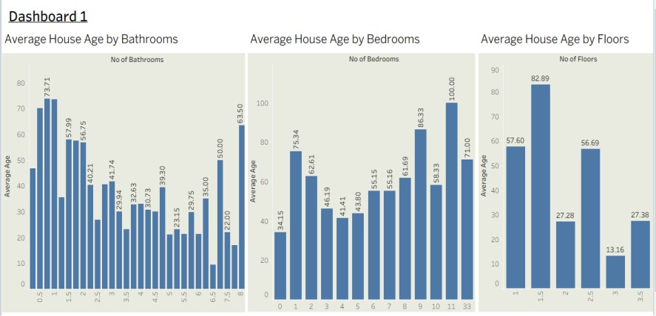  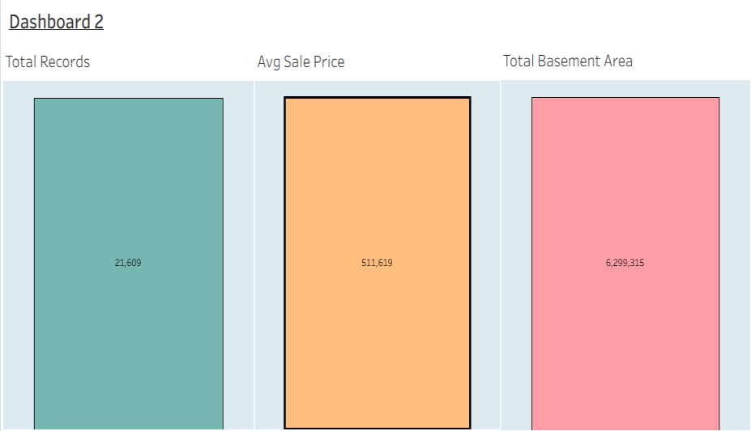

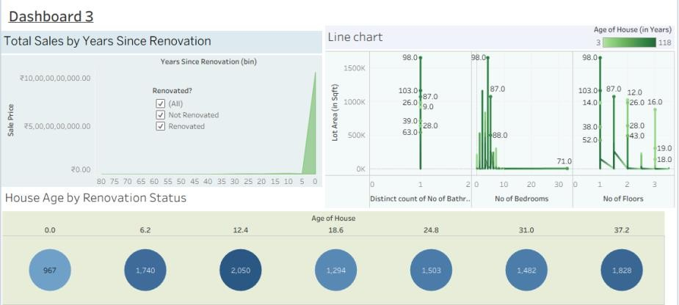

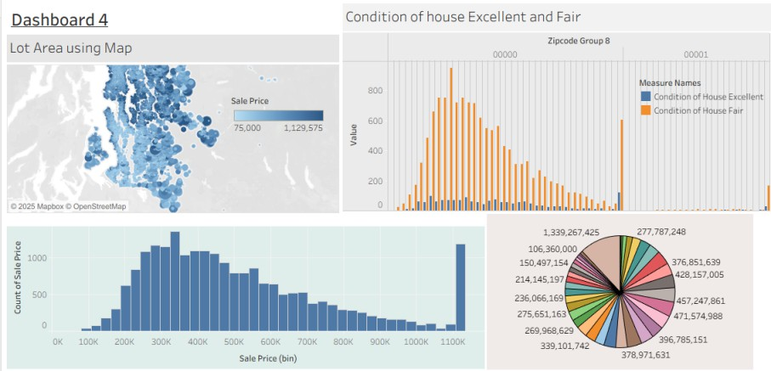
5. | Story Design | No of Visualizations / Graphs -14 slides.  